*Please check out the videos we provided for a more inclusive overview, real time feedback, and with more data in database.*

When user first opens the app, he is prompted with a welcome screen where he can login as patient, medical personnel or admin.

1. Patient Page

If he chooses to login as patient for example, he can choose to enter his credentials (username and password) and login or to register

Upon successful registration, the user will be prompted to login with his new credentials and then he can access his page. He can view his personal info, dose information, an option to download certificate that will only allow him to do so if both his doses were confirmed, and a logout button.

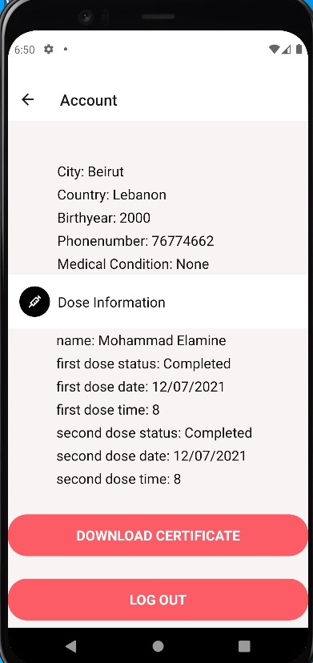

Also, upon successful registration, an email will be sent to the user scheduling a dose 1 date for him

For example,

Now if the user presses on download certificate, if his doses aren’t confirmed, an alert will pop up saying he needs to complete his doses before he can download, else if his doses are confirmed, an email is sent to him with his certificate his attached and he can download the certificate.

1. Medical Personnel

Now if the user were to login as a medical personnel:

In his account, he will have the options to search for a patient by phone number, and view all pending doses.

**Search by phone number**:

If the medical personnel entered a valid patient phone number, he can view that patient’s personal information (not all) and his dose history.

**View all pending doses**:

When the medical personnel presses on view all pending doses, he will be prompted a page that contains all doses that are still pending and not confirmed yet, along with their status, id, patient name date, and time.

And he will also have a button that would confirm any pending dose, so all the patient does is provide the id of the dose he wants to confirm, and press confirm.

**If the dose confirmed was a scheduled dose 1 appointment**, the patient will receive a mail from aubcovax00 stating that dose 2 was confirmed and will automatically schedule an appointment for him for dose 2.

**If the dose confirmed was a scheduled dose 2 appointment**, the patient will receive a mail from aubcovax00 stating that dose 2 was confirmed and he can now login and download his certificate.

1. **Admin Page**

The user can choose to login as admin:

When the user logs in as an admin, he will be presented with the following screen

He can search a patient by phone number, same as for medical personnel, and he can search a patient by name.

He can also press on view medical staff& patients which will return a list of all patients and medical personal that he can view and monitor.

**Database:**

We used MySql and mysql workbench and here are the sql tables we used, we also provided an export in the folder ‘db export’

SQL Tables:

